1. pnpm init
2. pnpm add -D typescript @types/node
3. pnpm tsc -–init || pnpm exec tsc –init
4. Check tsconfig to change the attributes
5. pnpm tsc <index.ts> to convert .ts -> .js file
6. Uncomment allowJs, outDir, rootDir in tsconfig.json to get the following command working.  
   -> pnpm tsc  
   —> converts all .ts to .js
7. 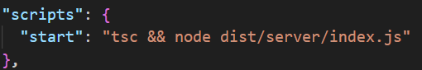
8. This is done so that tsc generates the file & index.js is run

With -> pnpm start

WITH tsx

1. pnpm add -D tsx



1. pnpm dev

WITH tsc-watch

1. Pnpm add -D tsc-watch

